

“**Experiment 1.5”**

**Student Name: SUMIT KUMAR UID: 20BCS8226**

**Branch: CSE Section/Group: DM-720 A**

**Semester: 6th Date of Performance: 10-04-23**

**Subject Name: MAD Lab Subject Code: 20CSP-356**

**Aim:**

Create an android app using radio button and checkbox.

**Objective:**

Understanding of the specific requirements and challenges when developing for a mobile context.

**System Requirements:**

1. Java Development Kit (JDK)

2. Java Runtime Environment (JRE)

3. Android Studio

**Script:**

**MainActivity.java :**

package com.example.exp5;

import androidx.appcompat.app.AppCompatActivity;

import android.os.Bundle;

import android.view.View;

import android.widget.Button;

import android.widget.CheckBox;

import android.widget.RadioButton;

import android.widget.Toast;

public class MainActivity extends AppCompatActivity {

Button b1, b2;

RadioButton r1, r2;

CheckBox c1, c2, c3;

@Override

protected void onCreate(Bundle savedInstanceState) {

super.onCreate(savedInstanceState);

setContentView(R.layout.activity_main);

okButton();

submitButton();

}

public void okButton(){

r1 = findViewById(R.id.radioButton);

r2 = findViewById(R.id.radioButton2);

b1 = findViewById(R.id.button);

b1.setOnClickListener(new View.OnClickListener() {

@Override

public void onClick(View view) {

String msg="";

if(r1.isChecked()) msg = msg + " Male ";

if(r2.isChecked()) msg = msg + " Female ";

Toast.makeText(MainActivity.this,msg + "are selected",Toast.LENGTH_SHORT).show();

}

});

}

public void submitButton(){

c1 = findViewById(R.id.checkBox);

c2 = findViewById(R.id.checkBox2);

c3 = findViewById(R.id.checkBox3);

b2 = findViewById(R.id.button2);

b2.setOnClickListener(new View.OnClickListener() {

@Override

public void onClick(View view) {

String msg="";

if(c1.isChecked()) msg = msg + " Cycling ";

if(c2.isChecked()) msg = msg + " Painting ";

if(c3.isChecked()) msg = msg + " Dancing ";

Toast.makeText(MainActivity.this,msg + "are selected",Toast.LENGTH_SHORT).show();

}

});

}

}

**Activity_main.xml :**

<?xml version="1.0" encoding="utf-8"?>

<androidx.constraintlayout.widget.ConstraintLayout xmlns:android="http://schemas.android.com/apk/res/android"

xmlns:app="http://schemas.android.com/apk/res-auto"

xmlns:tools="http://schemas.android.com/tools"

android:layout_width="match_parent"

android:layout_height="match_parent"

tools:context=".MainActivity">

<TextView

android:id="@+id/textView"

android:layout_width="wrap_content"

android:layout_height="wrap_content"

android:text="Choose Geneder"

android:textSize="20sp"

app:layout_constraintBottom_toBottomOf="parent"

app:layout_constraintEnd_toStartOf="@+id/textView2"

app:layout_constraintHorizontal_bias="0.156"

app:layout_constraintStart_toStartOf="parent"

app:layout_constraintTop_toTopOf="parent"

app:layout_constraintVertical_bias="0.076" />

<RadioGroup

android:layout_width="145dp"

android:layout_height="267dp"

app:layout_constraintBottom_toBottomOf="parent"

app:layout_constraintEnd_toEndOf="parent"

app:layout_constraintHorizontal_bias="0.165"

app:layout_constraintStart_toStartOf="parent"

app:layout_constraintTop_toTopOf="parent"

app:layout_constraintVertical_bias="0.262">

<RadioButton

android:id="@+id/radioButton"

android:layout_width="wrap_content"

android:layout_height="wrap_content"

android:text="20BCS8226"

app:layout_constraintBottom_toBottomOf="parent"

app:layout_constraintEnd_toStartOf="@+id/checkBox"

app:layout_constraintHorizontal_bias="0.076"

app:layout_constraintStart_toStartOf="parent"

app:layout_constraintTop_toTopOf="parent"

app:layout_constraintVertical_bias="0.143" />

<RadioButton

android:id="@+id/radioButton2"

android:layout_width="wrap_content"

android:layout_height="wrap_content"

android:text="Female"

app:layout_constraintBottom_toBottomOf="parent"

app:layout_constraintEnd_toEndOf="parent"

app:layout_constraintHorizontal_bias="0.048"

app:layout_constraintStart_toStartOf="parent"

app:layout_constraintTop_toTopOf="parent"

app:layout_constraintVertical_bias="0.25" />

<Button

android:id="@+id/button"

android:layout_width="wrap_content"

android:layout_height="wrap_content"

android:text="OK"

app:layout_constraintBottom_toBottomOf="parent"

app:layout_constraintEnd_toEndOf="parent"

app:layout_constraintHorizontal_bias="0.049"

app:layout_constraintStart_toStartOf="parent"

app:layout_constraintTop_toTopOf="parent"

app:layout_constraintVertical_bias="0.499" />

</RadioGroup>

<TextView

android:id="@+id/textView2"

android:layout_width="wrap_content"

android:layout_height="wrap_content"

android:text="Select Hobbies"

android:textSize="20sp"

app:layout_constraintBottom_toBottomOf="parent"

app:layout_constraintEnd_toEndOf="parent"

app:layout_constraintHorizontal_bias="0.905"

app:layout_constraintStart_toStartOf="parent"

app:layout_constraintTop_toTopOf="parent"

app:layout_constraintVertical_bias="0.076" />

<CheckBox

android:id="@+id/checkBox"

android:layout_width="wrap_content"

android:layout_height="wrap_content"

android:text="20BCS8226"

app:layout_constraintBottom_toBottomOf="parent"

app:layout_constraintEnd_toEndOf="parent"

app:layout_constraintHorizontal_bias="0.75"

app:layout_constraintStart_toStartOf="parent"

app:layout_constraintTop_toTopOf="parent"

app:layout_constraintVertical_bias="0.143" />

<CheckBox

android:id="@+id/checkBox2"

android:layout_width="wrap_content"

android:layout_height="wrap_content"

android:text="Painting"

app:layout_constraintBottom_toBottomOf="parent"

app:layout_constraintEnd_toEndOf="parent"

app:layout_constraintHorizontal_bias="0.746"

app:layout_constraintStart_toStartOf="parent"

app:layout_constraintTop_toTopOf="parent"

app:layout_constraintVertical_bias="0.25" />

<CheckBox

android:id="@+id/checkBox3"

android:layout_width="wrap_content"

android:layout_height="wrap_content"

android:text="Dancing"

app:layout_constraintBottom_toBottomOf="parent"

app:layout_constraintEnd_toEndOf="parent"

app:layout_constraintHorizontal_bias="0.762"

app:layout_constraintStart_toStartOf="parent"

app:layout_constraintTop_toTopOf="parent"

app:layout_constraintVertical_bias="0.371" />

<Button

android:id="@+id/button2"

android:layout_width="wrap_content"

android:layout_height="wrap_content"

android:text="Submit"

app:layout_constraintBottom_toBottomOf="parent"

app:layout_constraintEnd_toEndOf="parent"

app:layout_constraintHorizontal_bias="0.784"

app:layout_constraintStart_toStartOf="parent"

app:layout_constraintTop_toTopOf="parent"

app:layout_constraintVertical_bias="0.499" />

</androidx.constraintlayout.widget.ConstraintLayout>

**Output:**

**For radio button:**

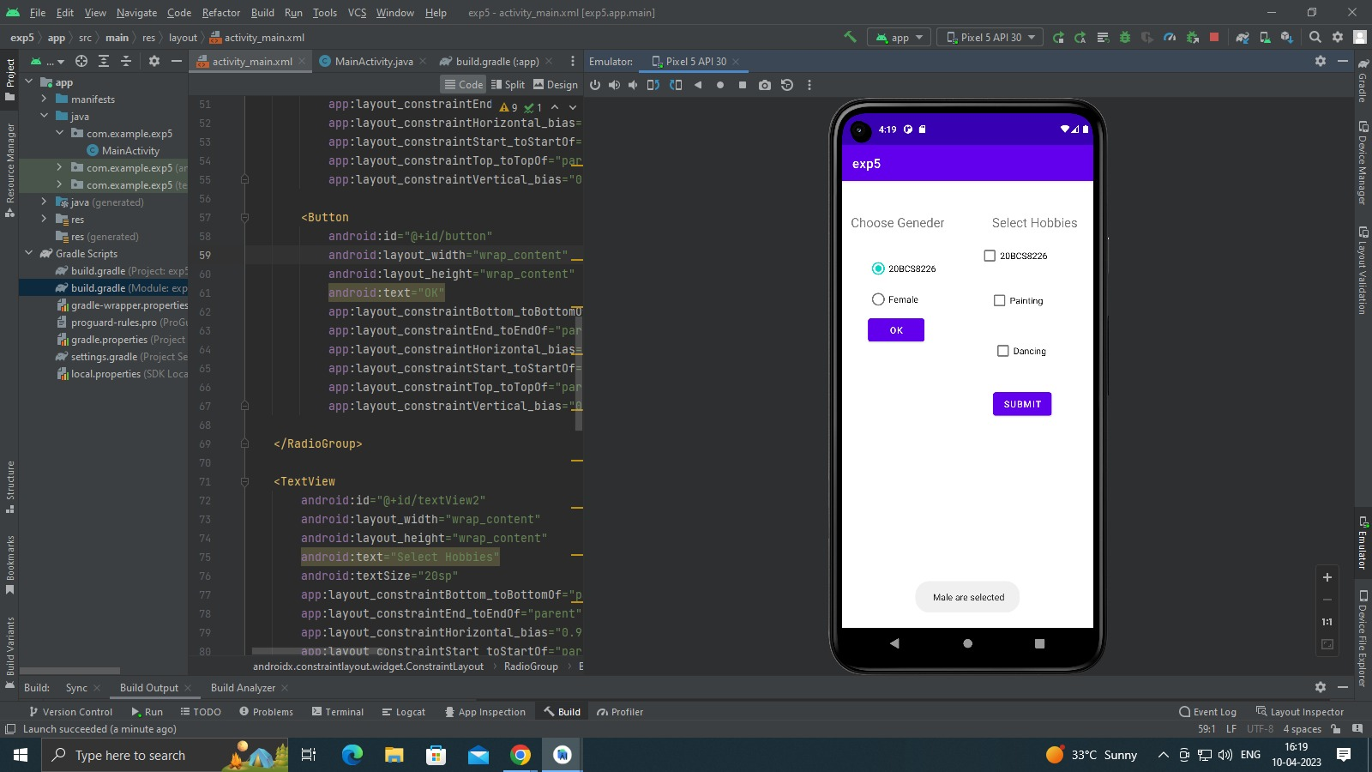

**For checkbox:**

